[Insert organisation name/logo]

REFERRAL DIRECTORY USER GUIDE

The Referral Directory User Guide provides information about your organisation referral contacts to support referral pathways between you and those services.

This user guide contains the following information:
- how the information is distributed in the directory
- how to move between tabs and browse information
- how to use filters
- how to use comments or notes

SECTION 1. INFORMATION DISTRIBUTION

The data in this directory is distributed across four tabs using Microsoft Excel. The tabs are identified as four steps in the process of finding the right service for your client. The steps and information on each tab are outlined below

SECTION 2: DIRECTORY FEATURES

Browsing the directory
You can browse the information by:
- moving from tab to tab
- using the scroll buttons on the bottom and right hand side of the screen
- using the filter options to identify specific requirements that suit.

Diagram 1: View of tab 1, main screen

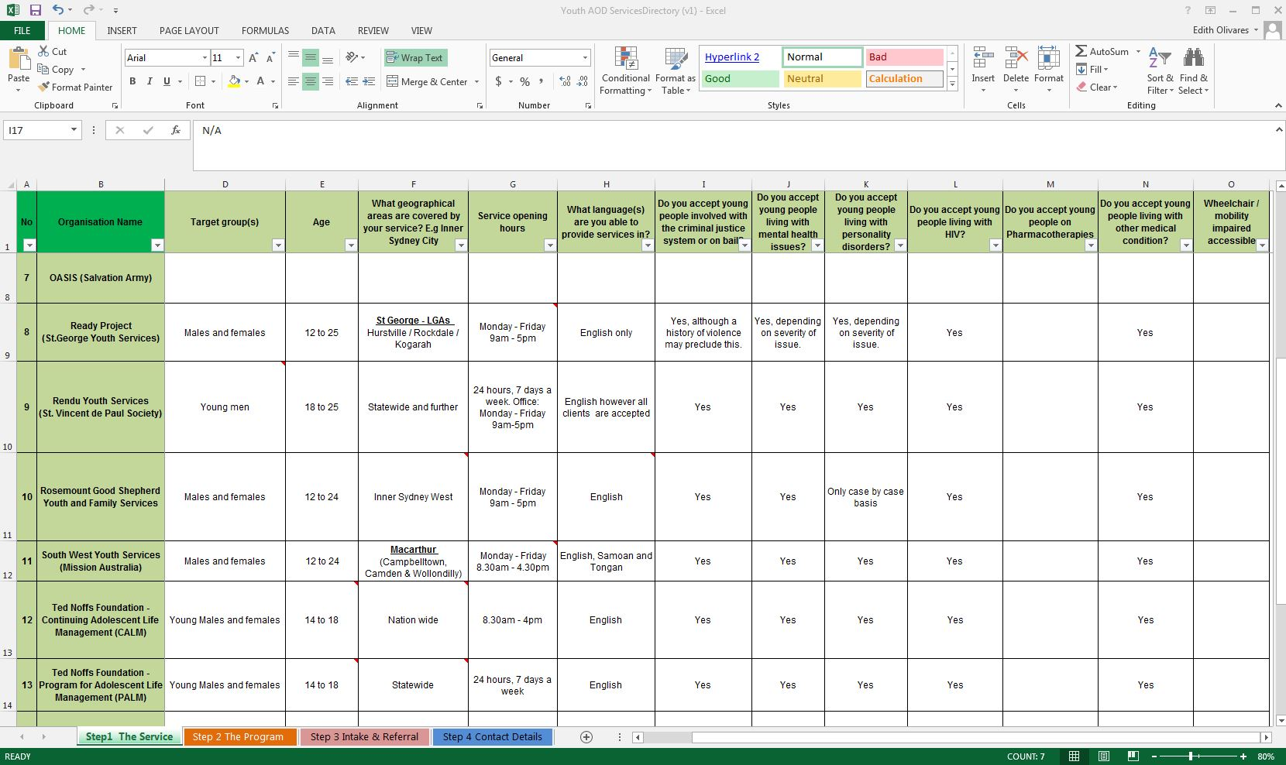

Click on the tab you want to view here.
Use the scroll button to move the screen left to right to view all the data (the first two columns will stay frozen so you always know what data relates to each service).
Scroll up and down here, or use the arrows on your keyboard.

SECTION 3: USING FILTERS

Filters are an easy way to identify specific criteria you are looking for without having to go through information that isn’t relevant. For example you can select to look only at residential services and the filter will remove any services that are not residential from the list you are looking at.

See the diagrams below for directions on how to use filters.

Diagram 2: Setting Filters

Select the type of services you would like to view and click Ok.
Use the search function to identify specific words.
Click on the drop down arrow to view your filtering options.

- Once you have selected your filter criteria only the services that meet that criteria will appear in the list.
- You can use as many filters as you choose across each tab.
- Remember that the second filter you apply will only filter information which met the criteria of your first, and so on.
- To start a new filter search you must deselect all the filters which have been applied.

Diagram 3: Recognising when filters are on

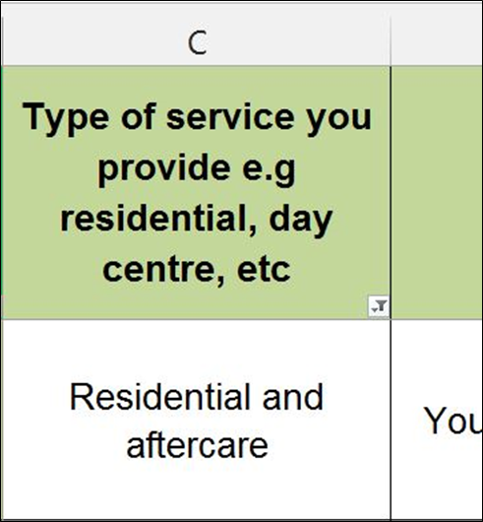
When a filter has been set you will see this symbol in the first cell of the column

Diagram 4: Turning filters off

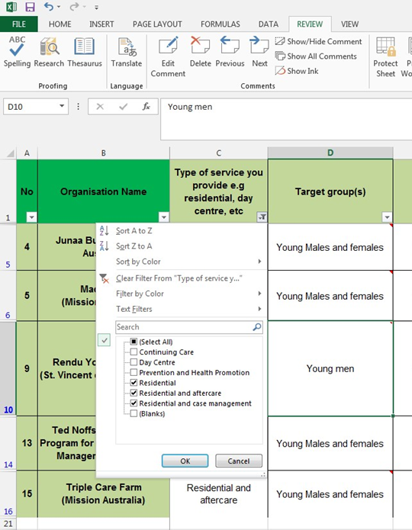
Click the select all option so all items in the list are selected and click ok.
Click the filter button and a drop down menu will appear.
Note: to deselect all filters you must do so in reverse order of those selected.

SECTION 4: COMMENTS

Comments are used to add more detail to the answer given to a particular question. For example the question may have a yes or no answer – keeping only the Yes or No response in the cells assists with filtering and search functions however a note can provide more information as to why the answer is yes or no.

You will note comments are already included in the Directory however you can edit, add or delete comments from your copy as you find out more information about different services and programs.

Diagram 5: Viewing comments

A red flag appears in the corner a cell when a comment is present.

Click on the cell and the comment will appear.

Diagram 6: Adding, editing or deleting a comment

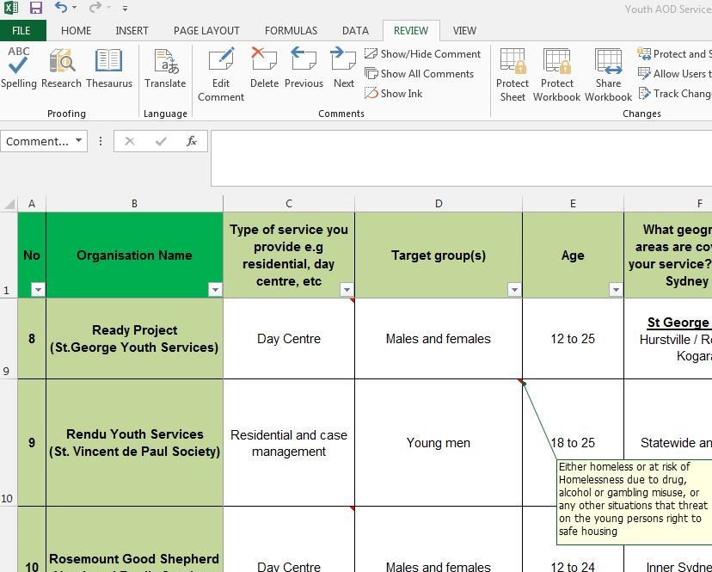
To edit, delete, add, show or hide a comment, select the cell you want to make changes to and go to the Review tool bar. You can then select the relevant option.

FOR MORE INFORMATION
For more information about the referral directory refer to the Client Administration Policy. For more information on particular services please contact the service directly.

