[Insert organisation name/logo]
[Insert organisation address]

EMERGENCY RESPONSE PLAN

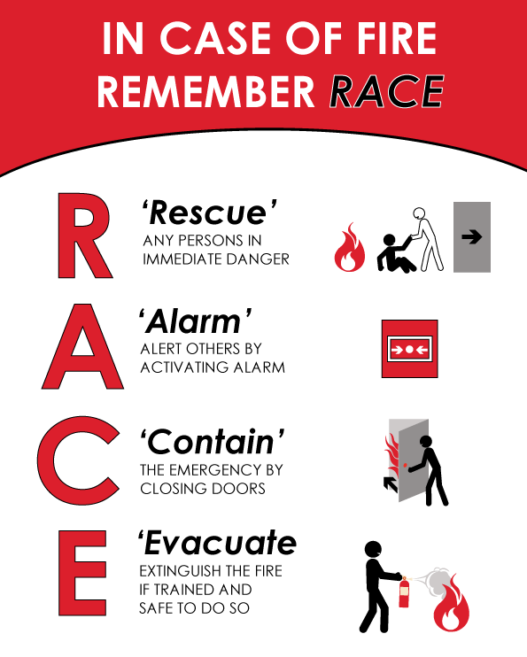

EMERGENCY EVACUATION

Emergency assembly area:
[Insert exact location of assembly area for e.g. corner of Hill and Sullivan Street]

[Insert assembly area map/photograph]
[Complete and identify the 2 items in the red boxes]

Emergency assembly area

[Insert organisation/office location point]

Here is an example of an Emergency Response Plan Poster

