[Insert organisation name/logo]

CLINICAL governance POLICY

Version: [Year/no]

Document status: Draft or Final

Date issued: [date]

Approved by: [insert organisation name] Board of Directors on [date]

Date for review: [date]

Record of policy development:

Version number | Date of issue | Lead author/ reviewer | Consultative panel | Significant changes on previous version
[Year/no] | [Date] | [Name/role] | [Name/role/ organisation] | [For example, incorporate changes to new legislation]

Note*
This policy template has been developed to meet the needs of a diverse range of services and includes items for consideration in policy and procedure.

Not all content will be relevant to your service. Organisations are encouraged to edit, add and delete content to ensure relevancy.

All material provided by the Network of Alcohol and other Drugs (NADA) is for guidance purposes only. The information should be reviewed in relation to your organisation’s individual circumstances and policies. NADA does not provide legal advice. You should seek your own advice in relation to any matters provided for in this policy or if you have any specific questions or concerns.

This policy may contain links to other websites. The links are provided for convenience only and may not remain current or be maintained. NADA is not responsible for the content or privacy practices associated with linked websites.
While every effort has been made to present all information accurately, NADA, its employees and related parties, accept no liability for, and do not indemnify against, any loss, damage or injury that may result from any actions taken based on the information contained in this document.

All notes (like this one) should be considered and deleted before finalising the policy, and the contents list should be updated as changes are made and when content is finalised. See the NADA Policy Toolkit User Guide for more editing tips.

*Please delete note before finalising this policy.

Note*
To update the contents list when all content has been finalised, right click on the contents list and select ‘update field’, an option box will appear, select ‘Update entire table’ and ‘Ok’.

To use the contents list to skip to relevant text, use Ctlr and click to select the relevant page number.

*Please delete note before finalising this policy.

SECTION 1: CLINICAL governance FRAMEWORK 4
1.1 Policy statement 4
1.2 Purpose and scope 4
1.3 Definitions 5
1.4 Principles 6
1.5 Outcomes 7
1.6 Delegations 8
1.7 Policy implementation 10
1.8 Risk management 11
SECTION 2: INTERNAL REFERENCES 13
2.1 Supporting documents 13
SECTION 3: EXTERNAL REFERENCES 14
3.1 Legislation 14
3.2 References 14
3.3 Other resources 14

SECTION 1: CLINICAL governance FRAMEWORK

1.1 Policy statement
[Insert organisation name]’s Clinical Governance Framework complements the general Governance policy and procedures but focusses specifically on the clinical aspects of the Organisation’s services.

1.2 Purpose and scope
This policy aims to guide [insert organisation name] in applying clinical governance processes across the its operations with the purpose of ensuring that:
- the Organisation’s goals and identified outcome priorities are achieved while ensuring
- the Organisation’s clients receive safe and high-quality care.

(Adapted from ACSQHC, 2017)

This policy applies to all of [insert organisation name]’s employees (both clinical and non-clinical), Board members, volunteers, student placements and visitors. All {insert organisation name]’s employees are expected to participate in maintaining effective and robust clinical governance, fulfilling their specified individual roles and responsibilities, as detailed in section 1.6 of this policy.

This policy applies to all of [insert organisation name]’s services and programs but it does not prescribe specific treatment interventions, counselling techniques, psychopharmacologies and medications.

For more detailed information on organisational governance, refer to [insert organisation name]’s Governance policy, Finance policy, and Human resources policy. For further information on Risk management, refer to section 1.8 of this policy.

1.3 Definitions

Board | The Organisation’s Board of Directors who are legally responsible managing body of the organisation.
Governance | Rules and structures setting out how an organisation is managed.
Clinical Governance | “A component of the corporate governance of health service organisations that ensures that everyone – from frontline clinicians to managers and members of governing bodies, such as boards – is accountable to clients and the community for ensuring the delivery of health services that are safe, effective, integrated, high quality and continuously improving” (ACQSHC, 2017).  As a component of broader systems for corporate governance, clinical governance involves a complex set of leadership behaviours, policies, procedures, and monitoring and improvement mechanisms that are directed towards ensuring good clinical outcomes. Clinical governance, therefore, needs to be conceptualised as a system within a system – i.e. a clinical governance system within a corporate governance system.
[Insert organisation name] Executive Group | The [insert organisation name] CEO, Deputy CEO and [insert other relevant staff member/s, e.g. Service Manager, Clinical Director].
Clinical Care Governance Group  [Note* Not every organisation or service will have a formalised Clinical Care Governance Group. For example, in a smaller organisation clinical feedback may be provided to the Board and management team by any staff member involved in the provision of clinical care. In this case, amend this section to align with your organisational processes.] | The Organisation’s group of experienced clinical professionals who provide guidance to the Board, and the Organisation as a whole, ensuring safe, effective, integrated, high quality and continuously improving clinical service delivery.
Clinical Incident | Any unplanned event resulting in, or having the potential to result in, harm to a client of the Organisation.
Clinical Risk Management | The process/s concerned with improving the quality and safety of services, first by identifying the circumstances and opportunities that put clients at risk of harm, and then by acting to prevent and/or control those risks. Organisational QI systems are inherently connected to Clinical risk management outcomes.
Clinical Incident Register | A register that assists the Organisation to comply with its legal risk management obligations by recording clinical incidents, the actions taken in response to each incident, and the roles/responsibilities of staff in identifying/responding to the incident.
Impact | Actual or potential effect or effects that have occurred, or may occur, as the result of a clinical incident.
Likelihood | The probability or chance of an incident occurring.
Mitigation strategy | A document that outlines the Organisation’s plan for response to an identified risk or incident, with the aim of reducing or eliminating the risk of an incident occurring.
Risk | The possibility of an event or incident occurring that will result in harm or otherwise negatively impact on the Organisation’s objectives. ‘Risk’ is measured in terms of the ‘likelihood’ of the event/incident occurring and the degree of ‘impact’ resulting from the event/incident.
Risk Assessment | The process of identifying, analysing and evaluating the likelihood and possible impact of potential risks that may be experienced by a client.
Risk Management | The process of identifying, analysing and judging risks, assigning ownership, takin actions to mitigate them, and monitoring and reviewing processes.
Risk Register | A tool for documenting risks, and actions to manage each risk. The Risk Register is essential to the successful management of risk. As risks are identified they are logged on the register and actions are taken to respond to the risk.
WHS | Work health and safety.

1.4 Principles
[Insert organisation name] adheres to the following principles in practicing clinical governance:
- Effective governance, leadership and culture: demonstrating a common organisational language in safety, quality and clinical governance and a ‘blame-free’, accountable and learning culture.
- Systems are in place that promote client safety and quality improvement: where opportunities for improvement are identified and system improvements are made to increase safety and quality of care.
- Clinical effectiveness and a commitment to the delivery of safe, high-quality care: with contracts, plans, strategies and policies supporting safety and quality of care (e.g. through clinical audits).
- Consumer involvement: that places partnerships with consumers, and their significant others, at the centre of care being provided.
- Managers, clinical and non-clinical staff are educated and build expertise on the clinical impact of decision-making: systems are in place to encourage continuing professional development through training and stakeholder partnerships.

Note*
These principles are based on the five (5) key components of an effective clinical governance framework as described in the National Safety and Quality in Health Service (NSQHS) Standards. The same 5 principles or ‘domains’ can also be depicted as a diagram, as illustrated below:

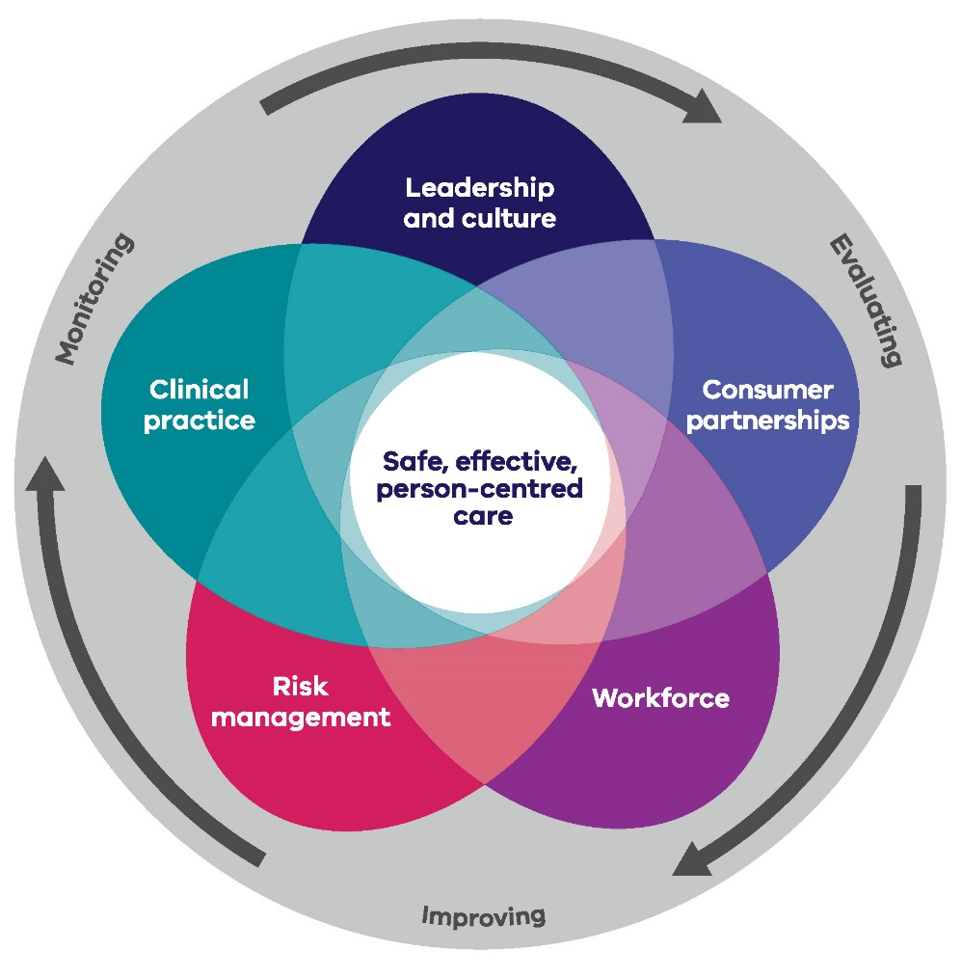
From: “ACT Health Clinical Governance Framework 2018-2023” (ACT Government, 2018)
*Please delete note before finalising this policy.

1.5 Outcomes
[Insert organisation name] demonstrates good clinical governance by ensuring:
- Continuous review and QI practices are taking place and are effective
- Clinical auditing is taking place and is effective
- Reporting structures (e.g. QI, clinical review) are in place and are effective
- Current processes include an effective clinical risk management system
- Sufficient workforce development activities are available in response to clinical incidents, changing trends and work practices
- Processes are in place to prevent reoccurrence of clinical incidents
- Consumer participation processes are in place and are effective
- Actions are minuted in clinical governance meetings and followed up.

Note*
The NSW Health ‘Drug and Alcohol Psychosocial Interventions: Professional practice guidelines’ (2008) provide detailed information on specific clinical governance activities and processes – namely, clinical supervision, clinical review, clinical line management, and clinical/medical documentation (see Section 8, pp. 67-70).
*Please delete note before finalising this policy.

1.6 Delegations

Board of Directors | - Endorse and ensure compliance with the Clinical Governance Policy.  - Familiarise themselves with legislative requirements of this Policy.  - Foster a ‘blame-free’ culture, promoting accountability and learning from clinical and governance challenges.  - Ensure that systems are in place to encourage continuing professional development through training and stakeholder partnerships.  - Be informed by the Clinical Care Governance Group and consumers in matters of clinical governance.
Business services/ Management | - Comply with the Clinical Governance Policy.  - Familiarise themselves with legislative requirements of this Policy.  - Foster a ‘blame-free’ culture, promoting accountability and learning from clinical and governance challenges.  - Implement and maintain systems and processes to increase the safety and quality of care.  - Be informed by the Clinical Care Governance Group and consumers in matters of clinical governance.  CEO/Manager  - Monitor the implementation and review of the Clinical Governance Policy.  - Allocate appropriate resources for staff training and development on clinical risk management.  - Ensure and monitor staff competence and compliance with this Policy.  - Collate/report information on adverse client events as required.  Management  - Support staff competence and compliance with this Policy.  - Operational decision-making is informed by this Policy.  - Provide professional support and supervision to staff; work in consultation with staff to develop and review Client Treatment Plans.  - Ensure staff receive appropriate training, supervision and debriefing to comply with this Policy.  - Collate/report information on adverse client events as required.  - Review/support the review of clinical processes.
Clinical Care Governance Group  [Or equivalent, as required.] | - Comply with the Clinical Governance Policy.  - Familiarise themselves with legislative requirements of this Policy.  - Inform and support operational decision-making relating to this policy.  - Identify clinical risk/s, notify management and act in accordance in providing duty of care.  - Maintain knowledge of the current evidence-based interventions available to clients.  - Be informed by consumers and other stakeholders in matters of clinical governance.
Program services/ Clinical AOD workers | - Comply with the Clinical Governance Policy.  - Familiarise themselves with legislative requirements of this Policy.  - Support operational decision-making relating to this policy.  - Identify “at risk” clients, notify management and act in accordance in providing duty of care.  - Provide consumer-centred care.  - Maintain knowledge of the current evidence-based interventions available to clients.  - Participate in regular clinical supervision.  - Where appropriate, maintain registration requirements with relevant associations and/or peak bodies.

Note*
If preferred, your organisation may choose to lay out the relevant clinical governance delegations of its employees in a diagram. For example:

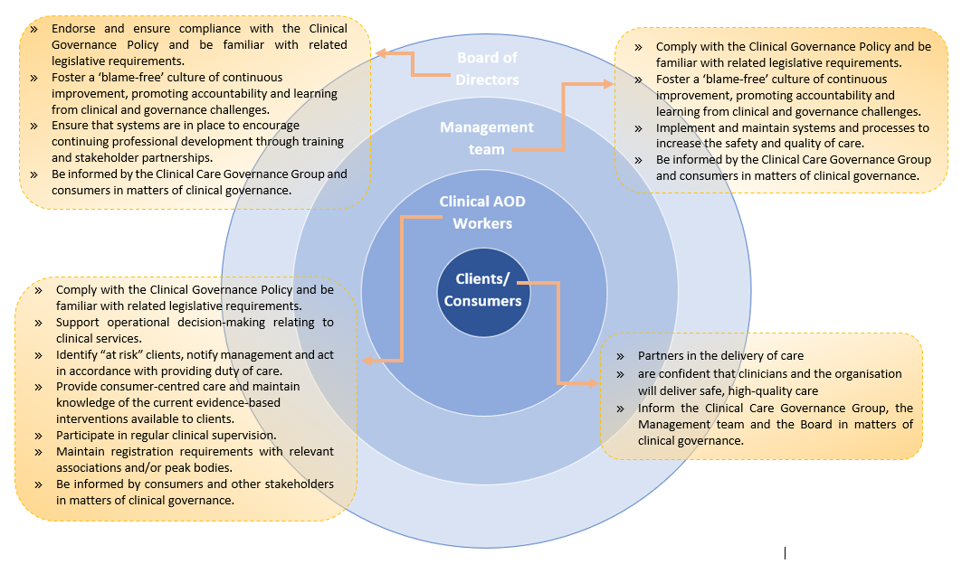(Adapted from ACSQHC, 2017)
*Please delete note before finalising this policy.

1.7 Policy implementation
This policy is developed in consultation with [insert organisation name] Board members, employees and consumers, and is approved by the Board of Directors. The Board align their governance input and decisions in line with the [insert organisation name] Clinical Care Governance Group.

This policy is part of all staff position descriptions (as relevant), orientation processes and all [insert organisation name] staff, Board members and volunteers are responsible for understanding and adhering to this Policy.

This Policy is underpinned by the [insert organisation name] Governance policy and is implemented in combination with all [insert organisation name]’s policies and procedures. This policy is also referenced in other relevant [insert organisation name] policies, procedures and supporting documents to ensure that it is actively used.

For the [insert organisation name] clinical governance policy to be effective, it must be implementable and implemented throughout the organisation, at the level of the Board and management, as well as at the clinical or service delivery level. Specific monitoring and support activities undertaken will include:
- Clinical review activities
[Insert organisation name] employees are required to participate in activities that identify, measure and analyse problems with the service and its delivery. For example,
- Regular meeting of the Clinical Care Governance Group [or revise as applicable to your organisation] with communication feedback to the Board, Management, clinical staff and external continuing coordinated care partners
- Client administration items on staff meeting agenda, where issues are raised and addressed
- Intake and assessment meetings, client file reviews, discharged client reviews
- Referral follow-ups and regular communication with referral stakeholders.

- Practice improvement
[Insert organisation name] employees work to improve the systems of service delivery by:
- having Risk register review as a standing agenda item for Board meetings
- reviewing this policy program every [insert timeframe], in line with the quality improvement, following a risk incident, and/or following relevant legislative changes
- reviewing this policy every [insert timeframe], in line with quality improvement cycles
- undertaking scheduled policy and procedure reviews, practice audits and other quality improvement processes.
- Human factors
[Insert organisation name] ensures that managers, clinical staff, development and delivery, and volunteers have:
- appropriate professional registration/accreditation, as stipulated by [insert organisation name] policy and required under State/Commonwealth legislation
- an understanding of clinical governance systems and how individuals and teams function within these systems
- orientation to this Policy and to the related policies and processes at the commencement of employment
- access to and familiarity with this policy, and an understanding of how it is implemented in practice.
- Consumers are engaged in review processes in a meaningful way [refer to Consumer Engagement Audit Tool]

[Insert organisation name] ensures robust clinical governance by maintaining a continuous cycle of feedback between the Board, management team, consumers and clinical employees, as informed by the Clinical Care Governance Group.

Note*
If preferred, your organisation may choose to lay out the relevant clinical governance delegations of its employees in a diagram. For example:
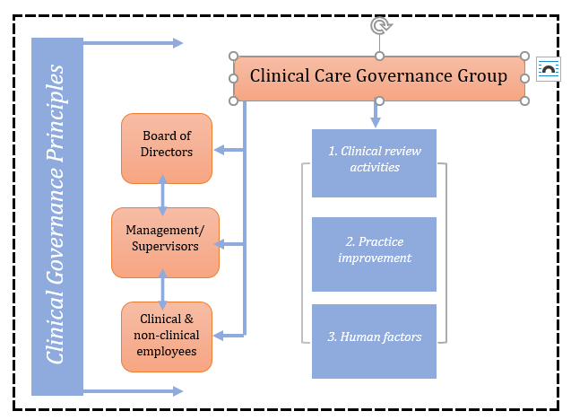
(Adapted from ACSQHC, 2017)

*Please delete note before finalising this policy.

1.8 Risk management

These governance policies and procedures are informed by, and comply with the Associations Incorporation Act 2009 (NSW) [or insert other relevant legislation]. The Board demonstrates that mechanisms are in place for fair and transparent governance through accessible meeting minutes, Board self-assessments and development plans. Annual performance reporting to members and stakeholders demonstrates transparency in governance and operations.

The clinical governance aspects of this policy and its procedures are informed by and comply with relevant legislation, including the Privacy Act 1988 (Commonwealth), Health Records and Information Privacy Act 2002 (NSW), Handbook to Health Privacy (2007), Public Health Act 1991 (NSW). For more information relating to Privacy and Confidentiality, refer to the [insert organisation name] Communications policy.
This policy is monitored using the [insert organisation name]’s QI Compliance Register which is a standing agenda item at staff and board meetings. Risks are also actively managed through [insert organisation name]’s Risk and Compliance register which is also reviewed at board meetings.
Policies are monitored by using the Risk and Compliance Register. All policies are reviewed every two years at a minimum, or following significant operational, policy or legislative requirements.

This policy is reviewed in line with the quality improvement program and is included in the [insert organisation name] policy review schedule where all policies are reviewed every [Insert frequency] at a minimum, or following significant operational, policy or legislative requirements.

Staff responsible for the clinical management of clients are adequately trained, supported and supervised to use evidence-based approaches and interventions.

Staff are aware of relevant legislation and duty of care provisions through induction, training and an assessment of their competencies prior to undertaking duties. All staff are supported to recognise the limits of individual roles and competencies and actively facilitate links to further levels of care where necessary.

For further information on clinical risk management, refer to [insert organisation name]’s guidelines for ‘Responding to serious clinical incidents’ [NADA template in development].

SECTION 2: INTERNAL REFERENCES

2.1 Supporting documents

The following NADA policy templates are available online via the NADA Policy Toolkit:
- Child protection and reporting template
- Client clinical management policy template
- Clinical supervision policy template
- Governance policy template
- Human resources policy template
- Financial management policy template
- Position description template
- Risk management policy template (in development)
- Suicide and self-harm prevention template

SECTION 3: EXTERNAL REFERENCES

3.1 Legislation
- National Safety and Quality Health Service (NSQHS) Standards. (ACSQHC, 2011).

3.2 References
- Australian Commission on Safety and Quality in Health Care (ACSQHC). National model clinical governance framework. Sydney: ACSQHC, 2017.
- NSW Department of Health. Clinical governance issues. From Section 8: NSW Health drug and alcohol psychosocial interventions professional practice guidelines (pp.67-70). Sydney: NSW Department of Health, 2008.
- Ross, P. & Lee, N. Clinical governance audit report (for Uniting Care/ReGen). Melbourne: LeeJenn Health Consultants, 2015.

3.3 Other resources
- ACT Health Clinical Governance Framework 2018-2023.
ACT Government, 2018.
Available at www.health.act.gov.au/sites/default/files/2019-02/ACT%20Health%20Clinical%20Governance%20Framework%202018-2023.pdf on 17th September 2019.
- Better Safer Care: Clinical Governance.
Victorian Agency for Health Information (VAHI), 2018.
Available at www.bettersafercare.vic.gov.au/our-work/governance/clinical-governance on 17th September 2019.
- Clinical and care governance strategy 2017-2019: Making quality real.
NHS Scotland, 2017.
Available at www.nhstaysidecdn.scot.nhs.uk/NHSTaysideWeb/idcplg?IdcService=GET_SECURE_FILE&Rendition=web&RevisionSelectionMethod=LatestReleased&noSaveAs=1&dDocName=prod_231679 on 17th September 2019.

- Clinical Governance: Corporate governance and accountability compendium.
NSW Health, 2019.
Available at www.health.nsw.gov.au/policies/manuals/Documents/cgc-section5.pdf on 17th September 2019.

