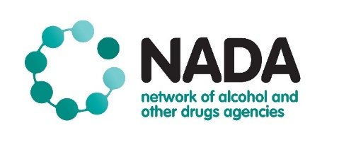
Gender and Sexuality Diverse AOD Worker Network
Terms of Reference

Establishment Date | December 2019
Chairperson/s | Robert Stirling (NADA)  Harper Dalton-Earls (Odyssey House)  Sarah Etter (Illawarra Local Health District)
Updates To: | NADA members and the broader NSW AOD sector
Secretariat: | NADA
Next Review | December 2020

Background:
Gender and sexuality diverse people are a priority in the National Drug Strategy, and other strategies related to alcohol and other drug (AOD) use. NADA has undertaken a range of activities to ensure its members are providing inclusive services, however there is still much more work to be done in this area. Additionally, a recent study by NADA found that 15% of non government AOD workers identified as gender and sexuality diverse. When asked workers reported an interest in creating a supportive network, raising visibility and improving services responses.

Purpose:
The network has a dual purpose to:
- provide a supportive network for gender and sexuality diverse workers in the AOD sector;
- improve AOD services for gender and sexuality diverse people.

Responsibilities and Functions:
Specifically, the members will be responsible for:
- Participating in regular network meetings
- Determining priorities through consultation, practice wisdom and experience, feedback from gender and sexuality diverse people accessing treatment
- Overseeing the development and implementation of an activity work plan, and assessment of its effectiveness annually

It is expected that all members will work together in a collaborative, respectful and collegiate way.

The Gender and Sexuality Diverse AOD Worker Network will aim to create spaces of mental and physical safety at all times, where people can express their identities and engage positively and fully within the network.

Decision Making:
Decisions will be reached by consensus. If this is not possible, then at least a two thirds majority agreement of meeting attendees is required – at the discretion of the Co-Chairs.

NADAs Responsibilities:
NADA has responsibility for providing secretariat support, communication and coordination of network activities.

Reporting Relationships:
An update of network activity will be provided to the NADA Board and Program staff and also the sector through email update and the NADA Advocate Newsletter. NADA will also update activity of the network to its funders.

Method of Evaluation:
Annual review of Terms of Reference against the work plan.

Quorum:
A quorum is required for all meetings of the network representing 50% of the membership plus one. At least one Co-Chair must be present at each meeting.

Privacy and Confidentiality
Where discussions and/or information are tabled at a network meeting that are of a sensitive nature they will be held in the strictest confidence – Chatham House Rules will apply.

Conflict of Interest:
It is the responsibility of all network committee members to make any conflict of interest known to the Chair. Where a committee member is deemed to have a real or perceived conflict of interest in a matter that is being considered at a meeting, the committee member may be excused from discussions and deliberations on the issue.

Membership:
The membership is comprised of NSW AOD workers. Workers are inclusive of those providing frontline services, management, administration and research.

