[Insert organisation name/logo]

# CLINICAL governance POLICY

**Version: [Year/no]**

**Document status: Draft or Final**

**Date issued: [date]**

**Approved by: [insert organisation name] Board of Directors on [date]**

**Date for review: [date]**

**Record of policy development:**

|  |  |  |  |  |
| --- | --- | --- | --- | --- |
| **Version number** | **Date of issue** | **Lead author/ reviewer** | **Consultative panel** | **Significant changes on previous version** |
| **[Year/no]** | **[Date]** | **[Name/role]** | **[Name/role/ organisation]** | **[For example, incorporate changes to new legislation]** |
|  |  |  |  |  |
|  |  |  |  |  |

***Note\****

*This policy template has been developed to meet the needs of a diverse range of services and includes items for consideration in policy.* ***Not all content will be relevant to your service.******Organisations are encouraged to edit, add and delete content to ensure relevancy.***

*All material provided by the Network of Alcohol and other Drugs (NADA) is for guidance purposes only. The information should be reviewed in relation to your organisation’s individual circumstances and policies. NADA does not provide legal advice. You should seek your own advice in relation to any matters provided for in this policy or if you have any specific questions or concerns.*

*While every effort has been made to present all information accurately, NADA, its employees and related parties, accept no liability for, and do not indemnify against, any loss, damage or injury that may result from any actions taken based on the information contained in this document.*

*This policy may contain links to other websites. The links are provided for convenience only and may not remain current or be maintained. NADA is not responsible for the content or privacy practices associated with linked websites.*

*All notes (like this one) should be considered and deleted before finalising the policy, and the contents list should be updated as changes are made and when content is finalised.*

*\*Please delete note before finalising this policy.*

***Note\****

*To update the table of contents when all content has been finalised, right click on the contents list and select ‘update field’, an option box will appear, select ‘Update entire table’ and ‘Ok’.*

*To use the contents list to skip to relevant text, use* ***Ctrl and click*** *to select the relevant page number.*

*\*Please delete note before finalising this policy.*

CLINICAL GOVERNANCE POLICY 1

SECTION 1: CLINICAL governance FRAMEWORK 3

1.1 Policy statement 3

1.2 Purpose and scope 3

1.3 Definitions 4

1.4 Principles 5

1.5 Outcomes 5

1.6 Roles and responsibilities 6

1.7 Policy implementation 7

1.8 Risk management 9

SECTION 2: INTERNAL REFERENCES 10

2.1 Supporting documents 10

2.3 External references 10

## SECTION 1: CLINICAL governance FRAMEWORK

### 1.1 Policy statement

**[Insert organisation name]**’s Clinical Governance Framework complements the general Governance policy and focuses specifically on the clinical aspects of the Organisation’s services.

### 1.2 Purpose and scope

This policy aims to guide **[insert organisation name]** in applying clinical governance processes across its operations with the purpose of ensuring that the Organisation’s goals are achieved while ensuring clients receive safe and high-quality care.

This policy applies to all **[insert organisation name]**’s employees (both clinical and non-clinical), Board members, volunteers, students on placement and visitors. All **[insert organisation name]**’s employees are expected to participate in maintaining effective and robust clinical governance, fulfilling their specified individual roles and responsibilities, as detailed in section 1.6 of this policy.

For more detailed information on organisational governance, refer to **[insert organisation name]**’s Governance Policy, Finance Policy, and Human Resources Policy

The below diagram indicates how clinical governance intersects with other areas of organisational governance:

(Adapted from ACSQHC, 2017)

### 1.3 Definitions

***Note\****  
*With regards to the roles listed in this section, we recognise that not all organisations will have a formalised Clinical Governance Committee. For example, in a smaller organisation, clinical feedback may be provided to the Board and management team by any staff member involved in the provision of clinical care. In this case, amend the table below to align with your organisational processes.*

*\*Please delete this note before finalising this policy.*

|  |  |
| --- | --- |
| **Board** | The Board of Directors are the legally responsible managing body of the organisation. |
| **Clinical Governance** | ‘A systematic approach to maintaining and improving the quality of patient care within a health system. It is about the ability to produce effective change so that high quality care is achieved. It requires clinicians and administrators to take joint responsibility for making sure this occurs’.[1] |
| **Clinical Governance Committee** | The Organisation’s group of experienced clinical professionals who provide guidance to the Board, and the Organisation as a whole, ensuring safe, effective, integrated, quality and continuously improving clinical service delivery. |
| **Clinical Incident** | Any unplanned event resulting in, or having the potential to result in, harm to a client using the service. |
| **Clinical Risk Management** | The process/s concerned with improving the quality and safety of services, first by identifying the circumstances and opportunities that put clients at risk of harm, and then by acting to prevent and/or control those risks. Organisational Quality Improvement (QI) systems areinherently connected to clinical risk management outcomes. |
| **Impact** | Actual or potential effects of a clinical incident. |
| **Risk** | The possibility of an incident occurring that will result in harm or otherwise negatively impact on the Organisation’s objectives. ‘Risk’ is measured in terms of the likelihood of the incident occurring, and the degree of ‘impact’ resulting from the incident. |
| **Risk Management** | The process of identifying, analysing and judging risks, assigning ownership, taking actions to mitigate them, and reviewing processes. |
| **Risk Register** | A tool for documenting risks and actions to manage each risk. The Risk Register is essential for the successful management of risk. As risks are identified they are logged in the register and actions are taken to respond to the risk. |

### 1.4 Principles

**[Insert organisation name]** adheres to the following principles in practicing clinical governance:

1. **Effective governance, leadership and culture**: demonstrating a common organisational language in safety, quality, and clinical governance.
2. **Risk management**: opportunities for quality improvement are identified, and system improvements are made to increase client safety and quality of care.
3. **Clinical practice:** there is a commitment to the delivery of safe,high**-**quality care, with contracts, plans, strategies and policies supporting safety and quality of care (e.g. through clinical audits).
4. **Partnerships with clients:** Clients and their significant others are placed at the centre of care provided.
5. **Workforce:** all staff are educated and have expertise in the clinical impact of decision-making. Systems are in place to encourage continuing professional development through training and stakeholder partnerships.

***Note****\**

*The above principles are based on the five (5) key components of an effective clinical governance framework as described in the National Safety and Quality in Health Service (NSQHS) Standards.*

*\*Please delete note before finalising this policy.*

### 1.5 Outcomes

**[Insert organisation name]** demonstrates good clinical governance by ensuring:

* Provision of quality care for clients and alignment with the NSW Health Clinical Care Standards
* Continuous review and QI practices are taking place and are effective
* Clinical auditing is taking place and is effective
* Reporting structures (e.g. QI, clinical review) are in place and are effective
* Current processes include an effective clinical risk management system
* Sufficient workforce development activities are available in response to clinical incidents, changing trends, work practices and staff development needs
* Processes are in place to prevent recurrence of clinical incidents
* Consumer participation processes are in place and are effective
* Actions are noted in clinical governance meetings and followed up.

***Note****\**

*The Ministry of Health ‘Alcohol and other Drugs Psychosocial Interventions: Practice Guide’ (2023) provides information on specific clinical governance activities and processes like clinical supervision, clinical review and clinical line management. See also the NSW Clinical Care Standards (2020).*

*\*Please delete this note before finalising this policy.*

1.6 Roles and responsibilities  
All workers and Board members should familiarise themselves with, and ensure compliance with, this policy. Other responsibilities include:

|  |  |
| --- | --- |
| **Board of Directors** | * Endorse the Clinical Governance Policy. * Foster a ‘blame-free’ culture, promoting accountability and learning from clinical and governance challenges. * Ensure that systems are in place to encourage continuing professional development through training and stakeholder partnerships. * Be informed by the Clinical Governance Committee and clients in matters of clinical governance. |
| **Business services/ Management** | * Foster a ‘blame-free’ culture, promoting accountability and learning from clinical and governance challenges. * Implement and maintain systems to increase the safety and quality of care. * Be informed by the Clinical Governance Committee and clients in matters of clinical governance.   **CEO/Manager**   * Monitor the implementation and review of the Clinical Governance Policy. * Allocate appropriate resources for staff training and development on clinical risk management. * Ensure staff competence and compliance with this Policy. * Collate/report information on adverse client events as required.   **Management**   * Support staff competence and compliance with this Policy. * Operational decision-making is informed by this Policy. * Provide professional support and supervision to staff; work in consultation with staff to develop and review client care plans. * Ensure staff receive appropriate training, supervision and debriefing to comply with this Policy. * Collate/report information on client incidents as required. * Review/support the review of clinical processes. |
| **Clinical Governance Committee** *[Or equivalent, as required.]* | * Inform and support operational decision-making relating to this policy. * Identify clinical risk/s, notify management and act in accordance with appropriate risk management in providing duty of care. * Maintain knowledge of the current evidence-based interventions available to clients. * Be informed by clients and other stakeholders in matters of clinical governance. |
| **Program services/ Clinical AOD workers** | * Support operational decision-making relating to this policy. * Identify “at risk” clients, notify management and act in accordance with appropriate risk management in providing duty of care. * Provide person centred care. * Maintain knowledge of the current evidence-based interventions available to clients. * Participate in regular clinical supervision. * Where appropriate, maintain registration requirements with relevant associations and/or peak bodies. |

***Note\****

*If preferred, your organisation may choose to lay out the relevant clinical governance delegations of its employees in a diagram. For example:*

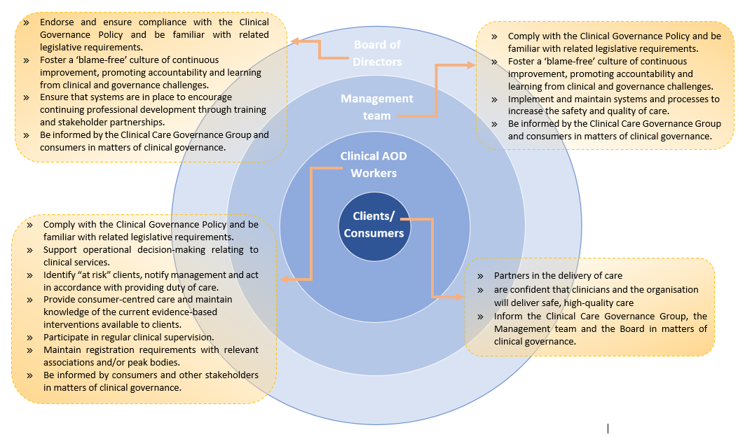*(Adapted from ACSQHC, 2017)  
  
*Please delete note before finalising this policy.*

### 1.7 Policy implementation

This policy is developed in consultation with **[insert organisation name]** Board members, employees and consumers. The Board align their governance input and decisions with the **[insert organisation name]** Clinical Care Governance Committee.

This policy is part of all staff position descriptions (as relevant) and orientation processes. All **[insert organisation name]** staff, Board members and volunteers are responsible for adhering to this Policy.

This Policy is underpinned by the **[insert organisation name]** Governance Policy.  This policy is also referenced in other relevant **[insert organisation name]** policies and supporting documents to ensure it is actively used.

For the **[insert organisation name]** clinical governance policy to be effective, it must be implemented throughout the organisation, including at the Board level. Specific monitoring and support activities will include:  

1. Clinical review activities

**[Insert organisation name]** employees are required to participate in activities that identify and analyse problems with the service and its delivery- for example:

* Regular meeting of theClinical Governance Committee **[or revise as applicable to your organisation]** with communication feedback to the Board, Management, clinical staff
* Client administration items on the staff meeting agenda, where issues are raised and addressed
* Intake and assessment meetings, client file reviews, clinical review meetings and discharged client reviews
* Referral follow-ups and regular communication with referral stakeholders.

1. Practice improvement

**[Insert organisation name]** employees work to improve the systems of service delivery by:

* having Risk Register review as a standing agenda item for Board meetings
* Undertaking audits in line with quality improvement and accreditation requirements
* reviewing this policy every **[insert timeframe]**, in line with the quality improvement, following a risk incident, and/or following relevant legislative changes

1. Human factors

**[Insert organisation name]** ensures that managers, clinical staff, development and delivery, and volunteers have:

* appropriate professional registration/accreditation, as stipulated by **[insert organisation name]** policy and required under State/Commonwealth legislation
* an understanding of clinical governance systems and how individuals and teams function within these systems
* orientation to this Policy-and related policies and processes- when commencing employment
* access to and familiarity with this policy, and an understanding of how it is implemented.
* Clients are engaged in review processes in a meaningful way (refer to the NADA Consumer Engagement Audit Tool, and the Consumer Engagement Policy).

**[Insert organisation name]** ensures robust clinical governance by maintaining a continuous cycle of feedback between the Board, management team, clients and clinical employees, as informed by the Clinical Care Governance Committee.

***Note***\*

If preferred, your organisation may choose to lay out the relevant clinical governance delegations of staff in a diagram. For example:

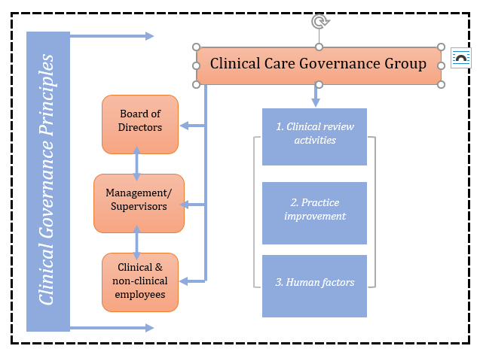

**Clinical Care Governance Committee**

*(Adapted from ACSQHC, 2017)*

*\*Please delete note before finalising this policy.*

### 1.8 Risk management

This policy is informed by and complies with the legislation listed in section 2.3. The organisation’s governance policies broadly are informed by and comply with the *Associations Incorporation Act 2009*(NSW) **[or insert other relevant legislation]**.   
  
The Board demonstrates that mechanisms are in place for fair and transparent governance through accessible meeting minutes, Board self-assessments and development plans.  Annual performance reporting to members and stakeholders demonstrates transparency in governance and operations.

Risk is also managed through compliance with the Risk Management Policy, noting risks in the Risk Register where needed, and ensuring compliance with legislation through the Compliance Register.

## SECTION 2: INTERNAL REFERENCES

### 2.1 Supporting documents

* Client drug overdose risk management plan
* Home visiting risk management plan
* Mental health related episodes risk management plan

**2.2 Related policy and procedure**

* Governance Policy
* Child Protection and Reporting Policy
* Risk Management Policy
* Human Resources Policy
* Financial Management Policy
* Client Clinical Management Policy
* Clinical Supervision Policy
* Suicide and Self-Harm Prevention Policy

### 2.3 External references

* *Privacy Act 1988* (Cth)
* *Health Records and Information Privacy Act 2002* (NSW)
* *Public Health Act 1991 (NSW).*
* [National Model Clinical Governance Framework | Australian Commission on Safety and Quality in Health Care](https://www.safetyandquality.gov.au/our-work/clinical-governance/national-model-clinical-governance-framework" \l "clinical-governance-and-the-national-model-clinical-governance-framework)
* NSW Ministry of Health, Alcohol and other Drugs Psychosocial Interventions: Practice Guide, Sydney: NSW Ministry of Health, 2023.

1. NSW Health (2023) ‘[Clinical governance in drug and alcohol’](https://www.health.nsw.gov.au/aod/professionals/Pages/clinical-governance.aspx), *NSW Health* 